

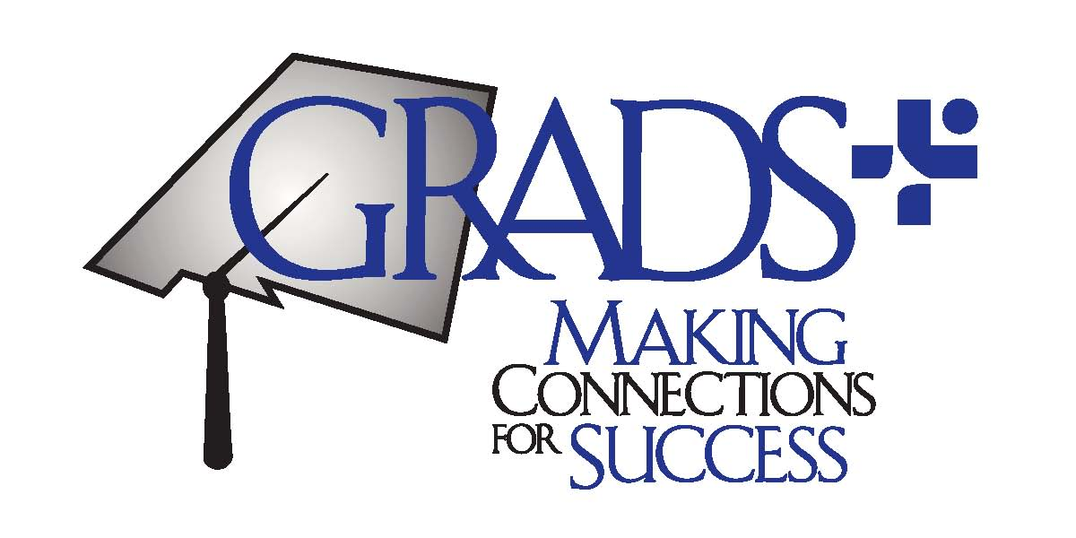

It Takes GRADS, School and Community to Support a Teen Family
Making Connections for Success: GRADS+ Training
Day One: October 14, 2015

Registration, Welcome and Year 3 Activities

8:00-8:30 am: Registration and Continental Breakfast

8:30-8:45 am: Welcome and Introductions, Sally Kosnick, GRADS

8:45-9:30 am Overview of Year 3 Grant Activities, Jessica Aufrichtig, PED

Let’s Talk Data: Understanding the Needs of Young Parents

9:00-9:30 am GRADS+ Model, Data Collection, and Quality Improvement

9:30-9:40 am Enrollment and Exit Forms, Jeanne Johnston

9:40-10:15 am Electronic Student Needs Questionnaire,
Jeanne Johnston and Julie Dutchover (Los Lunas GRADS)

10:15-10:30 am Break : Visit the booths!
Youth Resiliency Project, Adolescent Sexual Health, Gabrielle Abousleman (PED)
Homelessness and McKinney-Vento, Dana Malone (PED)
Teen Dating Violence, Heather Sandoval (AGO)
Fetal Alcohol Syndrome, Jerome Romero (UNM)
Know UR Rights, Liz McGrath (Pegasus) and Caitlin Adams (Envision)
Evaluation and Needs Assessment, Shannon Morrison, (Apex Education)

10:30-11:15 am Agency Linkage Form
Jessica Aufrichtig
Alysia Trujillo and Jennifer Elfein (Hatch GRADS)

11:15-11:30 GRADS Engagement and Satisfaction Survey, Apex

11:30-12:00 pm Child Support Enforcement Division, Anisa Goodman-La Cour

12:00-12:15 GRADS Award Ceremony

12:15-1:15 Lunch
Visit the Booths!

GRADS Teachers (1:15-4:00)

1:15-1:45 Ice Breaker

1:45-3:30 Rotating Roundtables (20 minutes each)

Table #1: Mock GRADS Advisory Committee,
Table #2: Legislative Connections
Table #3: Project-Based Activity

3:30-4:00 Debriefing, Q & A

GRADS Case Managers and Fatherhood Mentors (1:15-4:00)

Case Managers
1:15-2:00 GRADS+ Case Management Model, Jessica Aufrichtig

2:00-2:30 Building Rapport, Melody Richins, Hidalgo Medical Services

Fatherhood Mentors
1:15-2:30 Providing Services to Young Fathers
Johnny Wilson and Barry McIntosh, Young Fathers of Santa Fe

2:30-2:40 Break

2:40-4:00 Rotating Roundtables (20 minutes each)
Table #1: Linda Marquez (Silver City) and Carol White (Independence HS)
Table #2: Margie Tarango, Portales
Table#3: Brad Hofmann, Socorro
Table#4: Fathers Moving Forward, Patricia Heffelinger

4:00-4:30 Perspective of a Young Father, Fego Duran

4:30-5:00 Evaluation
Turn in sign booth sign-up sheets

Day Two: Wednesday October 14, 2015

Mental Health First Aid

8:30-9:00 Sign-in and Continental Breakfast

9:00-12:00 Mental Health First Aid
Suzanne Pearlman, Community Outreach, Communications and Training Manager (CYFD)
Clint Jon Pyeatt, UNM Salud

12:00-12:45 Working Lunch
Pregnant?-Preventing Teen Pregnancy
Chris Schueler Documentary

12:45-4:00 Mental Health First Aid, Continued

4:00-4:15 Wrap Up

