NM GRADS Enrollment and Exit Forms
www.nmgrads.net

REMINDERS:
- When entering information on the “teacher side”, remember this process:
  - Click on student’s name. This will bring up the demographic info.
  - Enter the demographic information for each student. This information will carry over from year to year.
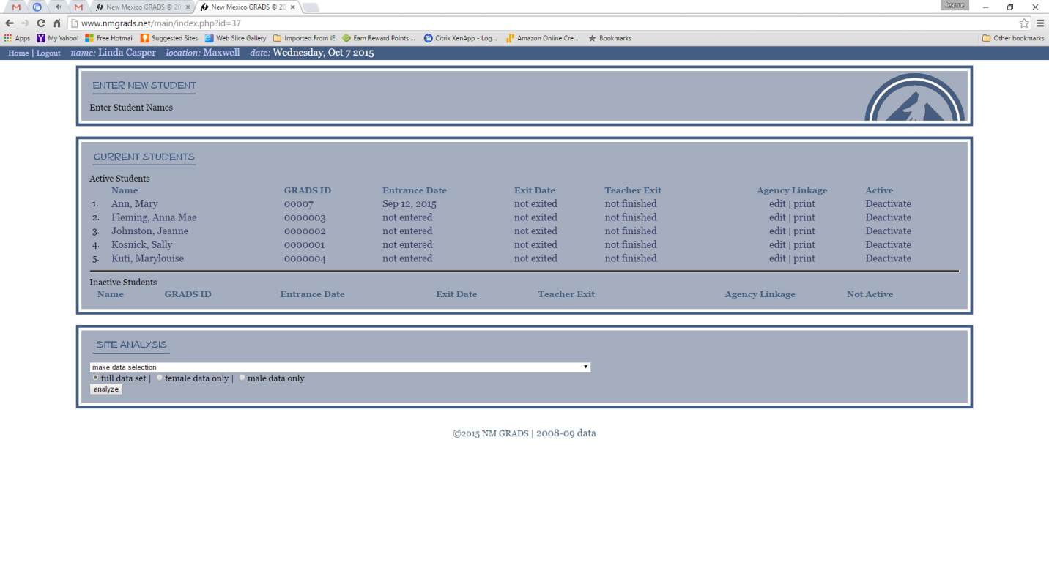

- Post Graduates:
  - If you are working with post graduate students, be sure to click post-graduate in all applicable sections on the teacher exit section.
  - The graduation information collected on the exit form is only for those GRADS students who graduated during that current school year.
- Check all the Services that the student received from GRADS:
  - Please make sure to mark these services on the teacher exit section
  - n. This is one area that we need to be sure is correctly reported. Most of the GRADS students should be receiving many (if not all) of the services listed.

If you have any questions, please contact Jeanne Johnston at the
GRADS state office- 575-835-1785, or jjohnston@nmgrads.org

